**ZETECH UNIVERSITY**



**FACULTY/DEPARTMENT OF ICT**

**DENNIS KELI MULEI**

**DBIT-01-8235/2021**

**DIPLOMA IN BUSINESS INFORMATION TECHNOLOGY**

**DBIT 506**

**ONLINE COLLEGES NEAR-ME LOCATOR SYSTEM**

**MR. BONIFACE MWANGI**

**DECEMBER, 2022**

**TABLE OF CONTENTS**

**DECLARATION** i

**ACKNOWLEDGEMENT** ii

**DEFINITION OF KEY TERMS** iii

**ABBREVIATIONS AND ACRONYMS** iv

**ABSTRACT** v

**LIST OF FIGURES** v

**LIST OF TABLES** vi

**CHAPTER ONE: INTRODUCTION AND BACKGROUND** 1

**1.1** **Introduction** 1

**1.2** **Problem statement** 1

**1.3** **General Objective** 1

**1.4** **Specific Objectives** 1

**1.5** **Background Information** 1

**1.6** **Significance of the study** 2

**1.7** **Study Limitation** 2

**1.8** **Problem Scope** 2

**CHAPTER TWO: LITERATURE REVIEW** 4

**2.1 Introduction** 4

**2.2 Theoretical Review** 4

**3.1 Introduction** 10

**3.2 System Requirements Specification** 11

**3.2.1 Functional Requirements and non-functional requirements** 11

**3.3. Design** 12

**3.3.1 Low Level Design** 12

**3.3.2 High Level Design** 13

**3.4 Implementation / Development** 14

**3.4.1 Language(s), Frameworks and Other Technical Requirements** 14

**3.5 Testing** 15

**3.5.1 Functional Requirements Testing** 15

**3.5.2 Non-Functional Requirements Testing** 15

**3.6 Deployment** 16

**CHAPTER FOUR: CONCLUSION AND RECOMMENDATIONS** 17

**4.1 CONCLUSION** 17

**1.2** **RECOMMENDATIONS** 17

**CHAPTER FIVE: REFERENCES AND APPENDICES** 19

**5.1 REFERENCES** 19

**5.2 APPENDIX I: PROJECT BUDGET** 19

**5.4 APPENDIX II: GANTT CHART** 20

# **DECLARATION**

This project report and the contents therein are my own personal and diligent work of research and have not been plagiarized in any way neither submitted in this exact fashion before to Zetech University for the award of a Diploma in Business Information Technology. The thesis has been complemented by referenced sources duly acknowledged. Where text, data (including spoken words), graphics, pictures or tables have been borrowed from other sources, including the internet, these are specifically accredited and references cited using the current APA system and in accordance with anti-plagiarism regulations.

# **ACKNOWLEDGEMENT**

I specially and cordially thank my unit instructor, Mr. Boniface Mwangi for providing much needed guidance for application of what I had learnt in class. Special thanks go to my family and friends for the great support they offered me throughout the project. I would also like to acknowledge the entire Zetech fraternity particularly the department of ICT for giving me opportunity to study and availing all the needed sources to undertake this study to completion. I would like also to give a big shout out to all the informants for their time and cooperation in making these studies a success.

Last but not least, I would like to thank the Almighty God for His care and protection throughout the project period. May God bless you.

# **DEFINITION OF KEY TERMS**

1. **Database**- A database is an organized collection of structured information, or data, typically stored electronically in a computer system. A database is usually controlled by a database management system (DBMS).
2. **Criteria**- a principle or standard by which something may be judged or decided.
3. **Program-** a set of related measures or activities with a particular long-term aim.
4. **Comprehensive-** including or dealing with all or nearly all elements or aspects of something.
5. **Niche-** a comfortable or suitable position in life or employment
6. **Scholarship-** academic study or achievement; learning at a high level.
7. **Extracurricular-** (of an activity at a school or college) pursued in addition to the normal course of study.
8. **Landscape-** all the visible features of an area of land, often considered in terms of their aesthetic appeal.
9. **Alumni-** a former pupil or student, especially a male one, of a particular school, college, or university.
10. **Invaluable-** extremely useful; indispensable.
11. **Insight-** the capacity to gain an accurate and deep understanding of someone or something.
12. **Platform-** a raised level surface on which people or things can stand.
13. **Dissatisfactions-** lack of satisfaction.
14. **Obligation-** an act or course of action to which a person is morally or legally bound; a duty or commitment.
15. **Firewall-** is a network security device that monitors and filters incoming and outgoing network traffic based on an organization's previously established security policies.
16. **Components-** a part or element of a larger whole, especially a part of a machine or vehicle.
17. **Modules-** each of a set of standardized parts or independent units that can be used to construct a more complex structure, such as an item of furniture or a building.
18. **Authentication-** the process or action of proving or showing something to be true, genuine, or valid.
19. **Interface-** a point where two systems, subjects, organizations, etc. meet and interact.
20. **Module-** each of a set of standardized parts or independent units that can be used to construct a more complex structure, such as an item of furniture or a building.

# **ABBREVIATIONS AND ACRONYMS**

1. **API**- Application Programming Interface
2. **RDBMS**- Relational database management system
3. **AWS**- Amazon web services
4. **CLS**- College locator system
5. **HTTPS**- Hypertext transfer protocol
6. **SSL**- Secure socket layer
7. **PHP**- PHP Hypertext Preprocessor
8. **IIS**- Internet Information Services
9. **ASP**- Application Service Provider
10. **APA**- American Psychological Association
11. **GB**- Gigabyte
12. **SSL-** Secure Sockets Layer
13. **DFD-** Data Flow Diagram
14. **ERD-** Entity Relationship Diagram
15. **SQL-** Sequential Query Language
16. **RAM-** Read Access Memory
17. **GUI-** Graphical User Interface

# **ABSTRACT**

Online Colleges near-me Locator System is an advanced technology platform that allows students to search for colleges, universities, and other educational institutions based on their desired criteria. The system provides a comprehensive list of schools that meet the user's criteria and allows them to quickly compare and select the one that best meets their needs. The system also offers a range of support services such as online admissions, financial aid, and career counseling. Additionally, users can access up-to-date information on institution’s rankings, tuition fees, and other important details. The system is designed to make the college selection process easier and faster, while helping students make the best decision for their education.

# **LIST OF FIGURES**

Fig 3.1 Data flow Diagram

Fig 3.2

Fig 3.3

Fig 3.4

Fig 3.5

# **LIST OF TABLES**

Table 3.1

Table 3.2

Table 3.3

Table 3.4

Table 3.5

Table 3.6

Table 3.7

# **CHAPTER ONE: INTRODUCTION AND BACKGROUND**

## **Introduction**

Online Colleges near-me locator systems are designed to help prospective college students find the best college for their needs. They provide information about available schools, their admissions criteria, financial aid opportunities, and other important details. The systems also allow students to compare schools and narrow down their choices. By using online colleges near-me locator system, students can save time and energy by quickly finding the college that best meets their needs.

## **Problem statement**

The problem statement for Online colleges near-me locator system is to create a web-based application that allows users to quickly and easily search for colleges and universities in their area and to find detailed information about the schools they are interested in. The application should be able to provide information about each school's degree programs, enrollment information, tuition costs, admissions requirements, and other relevant data. The application should also include a search function that allows users to easily filter results by location, degree program, or other criteria.

### **General Objective**

The general objective of Online colleges near-me locator system is to provide users with an efficient, user-friendly platform to search, compare, and research different college and university programs, admission requirements, and tuition costs in one convenient place.

### **Specific Objectives**

1. Provide a comprehensive database of colleges and universities, including detailed information about each institution's location.

2. Allow users to search for colleges based on their desired location, major, and other criteria.

3. Allow users to compare college options side-by-side and make informed decisions about their education.

4. Develop a user-friendly interface that makes it easy for users to navigate the college locator system.

5. Allow users to save their search results and create personalized lists of colleges they are interested in.

6. Provide accurate and up-to-date information about college-related events in the user’s area.

## **Background Information**

Online Colleges near-me locator system is a tool that enables students to find and compare colleges based on specific criteria. It is an online search engine designed to help students and parents find the best college for their individual needs. College locator systems typically allow users to search by college name or location and can provide information about tuition costs, campus size, majors and minors, student life, and more. College locator systems can also provide information about financial aid and scholarship opportunities. College locator systems are typically provided by third-party websites, such as College Board or Niche.

## **Significance of the study**

The study of Online Colleges near-me locator systems is important as it can help students who are looking for colleges and universities to find the best match for their educational needs. By using a college locator system, students can compare different colleges and universities based on their criteria, such as location, tuition, majors, and more. The system can also help students narrow down their search to find the college that best meets their needs. Additionally, college locator systems can provide students with more detailed information about the colleges they are considering such as reviews, student demographics, and more. This information can help students make an informed decision about which college to attend.

## **Study Limitation**

1. The Online Colleges near-me locator system may not contain accurate or up-to-date information about the college, courses, fees, and other related details.

2. It may not be able to provide information about college criteria and admission procedures.

3. It may not be able to provide personalized recommendations based on user preferences and interests.

4. It may not be able to provide information about the student’s budget and financial aid options.

5. It may not be able to provide information about the college’s faculty, facilities, or other important aspects.

6. It may not be able to provide information about the college’s social life and extracurricular activities.

7. It may not be able to provide information about the college’s acceptance rate or the number of students admitted.

## **Problem Scope**

The scope of Online Colleges near me locator system is to provide a user-friendly and comprehensive website that allows users to search for and compare colleges and universities across the United States. The system should allow users to search by location, academic program, cost and other criteria to find the best college or university for their needs. The system should also provide detailed information about each college or university, including admission requirements, financial aid, student life and more. Additionally, the system should provide links to resources for students to learn more about college and university programs and the application process.

# **CHAPTER TWO: LITERATURE REVIEW**

## **2.1 Introduction**

Online Colleges near-me Locator System is a web-based tool designed to help students and parents find the best college to meet their needs. The system provides detailed information about college admissions, tuition, financial aid, housing, campus life, and much more. It is designed to be a one-stop shop for researching and comparing colleges. The College Locator System is a comprehensive way to search for, compare, and evaluate colleges to determine the best fit for any student. It can be used to find the perfect college for any student’s goals, needs, and budget.

## **2.2 Theoretical Review**

**2.2.1 Purpose of a college locator system**

A Online Colleges near-me locator system is a tool that helps students find colleges and universities that best meet their needs. It can provide information about admissions, financial aid, and academic programs. It can also provide information about nearby housing and amenities, as well as nearby points of interest. A college locator system can also be used to compare colleges and universities to help students determine which the best fit is for them.

**2.2.2 How college locator system is designed**

**2.2.2.1 System Design**

In designing, the process included defining the architecture, components, modules, interfaces, and data for a system to satisfy the needs of the end users. The following steps are followed in system design:

1. Requirements Gathering: The first step is to gather the requirements of the college locator system. This includes understanding the purpose of the system, identifying users and their needs, and understanding the scope of the project.

2. System Design: The next step is to design the system. This includes designing the database architecture, user interface, and data flow. It also includes designing the system's security measures and user authentication.

3. Implementation: Once the system is designed, the next step is to implement it. This includes writing the code, testing the system, and deploying it.

4. Maintenance: The final step is to maintain the system. This includes making sure the system is up to date, fixing any bugs, and adding new features. It also includes providing user support and responding to user feedback.

**2.2.2.2 Conceptual Design**

Conceptual design is a phase of a design where drawings are the primary factor focus. A good conceptual design comprised of the creation of an idea, exploration of the intentions of an idea and the representation of an idea in form of a plan.

The College Locator System (CLS) is a web-based application that allows students to search for colleges based on their preferences and desired criteria. The system should enable users to search for colleges by location, program, tuition, size, and other criteria. Users should also be able to compare colleges side-by-side and save their searches for future reference. The system should provide easy navigation and an intuitive user interface, allowing users to quickly and easily find the information they need. The system should also feature interactive maps and visuals to help give users a better sense of the college they are considering. The underlying database should be comprehensive and up-to-date, as well as secure and reliable. The system should also be accessible on a variety of devices, such as desktop computers, laptops, smartphones, and tablets. The College Locator System should be designed to be user-friendly, efficient, and secure. By providing an intuitive search experience, users should be able to quickly find the college that best fits their needs.

**2.2.2.3 Logical design**

There was need of coming up with a logical data model which contained all the needed logical and physical design choices and physical storage parameters needed to generate a design in a

Data Definition Language, which was then used to create a database.

Logical design pertains to an abstract representation of the data flows, inputs and outputs of the system. This was often conducted via modeling, which involved a simplistic and sometimes graphical representation of an actual system. In the context of systems design, modeling could undertake the following forms:

a) Entity Relationship Diagrams

b) Data flow diagrams

A College Locator System is a software application that allows users to search for colleges and universities based on their location and other criteria. The system should allow users to specify the type of college they’re looking for, such as public or private, two-year or four-year, and its location. The system should then display a list of colleges that meet the user’s criteria, along with their contact information and other relevant details. The system should include a database of college information, including contact information, tuition costs, enrollment information, and any other relevant details. It should also provide a mapping feature that allows users to view the locations of colleges on a map. The mapping feature should include an interactive map that allows users to zoom in and out, as well as click on individual colleges to view more information. The system should also provide a search feature, allowing users to quickly find colleges that meet their criteria. The search feature should allow users to search by location, type of college, and other criteria, such as tuition costs and enrollment numbers. The system should also include a reviews feature, allowing users to read and write reviews of individual colleges. Reviews should be rated on a star system, allowing users to quickly gauge the overall opinion of a college. Finally, the system should include an administrative panel that allows administrators to manage the database of colleges, as well as view user reviews and other information. The panel should include a user interface that allows administrators to quickly add and edit college information, as well as manage user accounts.

**2.2.2.3.1 Entity Relationship Diagrams**

The E-R Diagram was used in data modeling to set up an entity relational model of the system.

This involved determining the relationships between the various entities in the system and associating these entities with their attributes and attribute domains.

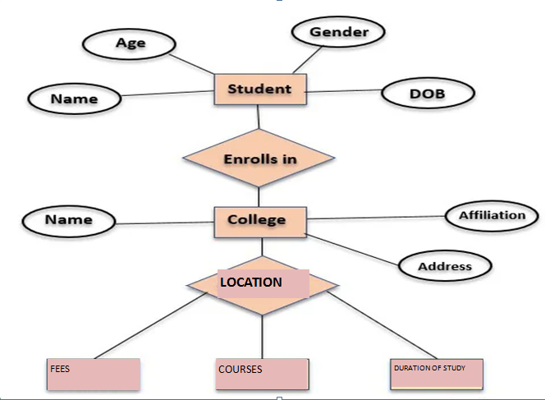

**LOCATION**

Fig 3.1

**2.2.2.3.2 Data Flow Diagram**

The Data Flow Diagram (DFD) was used to model the processes involved in the system to show how data flows into and out of the system in a top-down manner by giving a graphical representation of a system’s components, processes and how they will interface with each other.

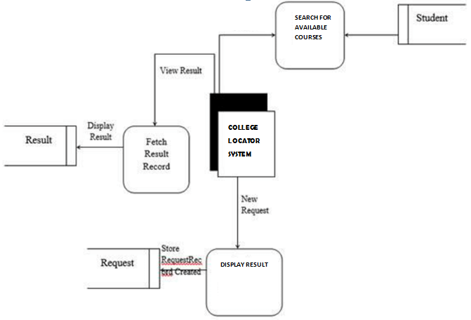

Fig 3.2

**2.2.3 Features and Functions of a college locator system**

**2.2.3.1 Search functionality**

The search functionality feature of a college locator system would allow users to search for college locations based on different criteria such as location, degree program, tuition costs, and student population size. It would also allow users to search for specific colleges by name or keyword. Additionally, users would be able to filter their search results by different criteria, such as geographic location, degree program, tuition costs, and student population size. This feature would enable users to quickly and easily locate the college that best meets their needs.

**2.2.3.2 Location-based Search**

This feature would allow users to search for colleges within a specified geographical area. The search could be done by entering the location (e.g. city, state, or zip code), or by selecting a radius from a specific location. The search results would list colleges within the specified area, along with information such as tuition costs, acceptance rates, and other relevant data. The location-based search feature would make it easier for students to find colleges in their area that meet their needs. It would also help them compare the cost and quality of different schools. Additionally, this feature would allow the college locator system to remain up-to-date with new schools and other changes in the local college landscape.

**2.2.3.3 School information**

The school information feature of a college locator system would provide users with the relevant information they need to make an informed decision on which college to attend. This feature would provide users with information such as the college’s location, size, tuition fees, admission requirements, academic programs and majors offered, student life, faculty and staff, alumni network, and other relevant information. Additionally, the system could also provide users with reviews, ratings, and feedback from previous students who attended the college. This feature would provide users with the necessary information to determine if the college is the right fit for them.

**2.2.3.4 Advanced filtering options**

The advanced filtering options feature of a college locator system allows users to customize their search based on their specific criteria. Users can filter their search by location, type of institution, size, tuition, and a variety of other factors. This feature provides users with more precise results that are tailored to their individual needs. It can also be used to compare different colleges and universities side-by-side to help users make an informed decision.

**2.2.4 Application Areas of a college locator system**

1. Student Assistance: A college locator system can assist students in finding the right college for their academic and career goals. It can provide information about college locations, cost of attendance, program offerings, and other important factors.

2. Academic Advising: A college locator system can help academic advisors match students with the right college based on their interests and goals. It can also provide detailed information about college programs and admissions requirements.

3. Financial Aid: A college locator system can help students and families find colleges that offer financial aid packages that meet their needs. It can provide detailed information about tuition and fees, scholarships, grants, and other forms of aid.

4. Recruitment: A college locator system can help recruiters find potential students to fill out their classes. It can provide detailed information about college admissions policies, demographics, and other factors that can help recruiters make informed decisions.

5. College Comparison: A college locator system can help students compare different colleges based on their interests and needs. It can provide detailed information about degree programs, tuition and fees, student life, and other factors.

**CHAPTER THREE: SYSTEM METHODOLOGY AND DATA COLLECTION**

## **3.1 Introduction**

College locator systems are designed to help students and their families find the right college fit. This system allows users to search for colleges based on criteria such as location, major, size, cost, and more. It can also provide detailed information about each college, including academic programs, campus life, and financial aid. The system can help users narrow down their options and make an informed decision about where to pursue their education. It can also help parents and students save time and money by avoiding colleges that may not be a good fit. Ultimately, a college locator system can be an invaluable tool for finding the perfect college for any student.

**3.1.1 Interviews**

This involved interviewing relevant persons in different areas on information concerning electronics repair shop management system. Through the interview, the researchers gave a chance to other respondents to ask all relevant questions concerning the topic of the study. This gave the researchers an advantage of getting firsthand information from the respondents.

A college locator system project report should include interviews with respondents to gain insight into the effectiveness of the system, as well as to identify areas of improvement. During the interviews, respondents should be asked questions about how they use the system, what features they like or dislike, and how it has impacted their decision-making process. Additionally, questions should be asked about how the system has changed the way they search for information, how quickly they can find what they need, and whether they find it easy and intuitive to use. Through these interviews, project team members can gain valuable feedback to help inform the design and implementation of the system, as well as to identify any areas of improvement.

**3.1.2 Review of existing documentation**

The existing documentation on a college locator system project report provides a comprehensive overview of the system and its components. The report begins with an introduction, which outlines the purpose and scope of the project. It then provides a detailed description of the system architecture and the various components, such as the user interface, database, and web services. The report also includes a discussion of the system requirements, including the input and output data formats, security and privacy considerations, and data integration options. Finally, the report ends with a summary of the project's deliverables, cost estimates, and timelines. Overall, the existing documentation provides a comprehensive overview of the project and its components, making it an invaluable resource for any project team.

**3.1.3 Observation technique**

An observation technique is a method of studying a system or process by observing and collecting data from it in order to gain insight into how it works, what problems it may have, and how it could be improved. In the context of a college locator system project, an observation technique would involve tracking the usage of the system in order to collect data related to the user experience. This data could include the amount of time it takes to complete certain tasks, the number of users who are able to complete the task, and the rate of abandonment of the system. This data can then be used to identify areas of improvement, such as making the navigation more intuitive or improving the speed of the system. Additionally, it can help identify areas where additional resources may be necessary, such as improving the quality of the search results or increasing the number of colleges included in the locator. By conducting an observation technique on the college locator system, the project team can gain valuable insights into how the system is performing and how it can be improved.

**3.1.4 Use of Questionnaire**

A questionnaire is a useful tool that can be used in a college locator system project report to gather information from potential users. This information can be used to assess the user’s preferences, needs, and expectations from the system. By understanding the requirements of the user, the project team can design and develop a system that meets the user’s needs. The questionnaire can be used to ask questions about the user’s experience with college locator systems, their expectations from the proposed system, and their level of satisfaction with the current system. The questionnaire can also be used to collect demographic information about the user so that the project team can develop a system that is tailored to the needs of different user groups. The questionnaire can also be used to assess the user’s understanding of college locator systems, their level of comfort in using them, and their views on how the system should be designed. This information can be used to help the project team to design a system that is intuitive and user-friendly. Overall, the questionnaire can provide valuable insight into the needs and expectations of potential users that can be used to inform the design and development of the college locator system.

## **3.2 System Requirements Specification**

### **3.2.1 Functional Requirements and non-functional requirements**

**Functional Requirements**

1. The system should allow users to search for colleges in their desired location by entering a city, state, or zip code.

2. The system should provide detailed information about each college, including its address, phone number, email address, website, tuition fees, and other related information.

3. The system should provide filtering options to search for colleges based on criteria such as degree offered, type of college, and size of college.

4. The system should provide users with the ability to compare colleges’ side-by-side in order to make an informed decision.

**Non-Functional Requirements**

The following non-functional requirements must be met by the system:

1. Usability: The system should be easy to use and navigate.

2. Reliability: The system should be reliable and always available when needed.

3. Security: The system should ensure the safety and privacy of user data.

4. Performance: The system should be able to handle a large number of searches efficiently.

5. Maintainability: The system should be easy to maintain and update.

6. Scalability: The system should be able to scale with the increasing number of colleges.

7. Accessibility: The system should be accessible across multiple devices and platforms.

## **3.3. Design**

### **3.3.1 Low Level Design**

Low-level design of college locator system involves the following steps:

1. Data Collection: The first step in the low-level design of a college locator system is to collect data about the colleges or universities. This data may include the name, address, contact information, programs offered, tuition fees, and other relevant information.

2. Database Design: The next step is to create a database that can store the collected data. This database should be able to store all the necessary information about the colleges and universities.

3. Interface Design: The interface should be designed in such a way that it is easy to use and understand for the users. It should provide easy access to the data stored in the database.

4. User Authentication: In order to ensure the security of the data, user authentication should be implemented. This will require the users to provide authentication information such as username and password in order to access the system.

5. Search Functionality: The system should allow users to search for colleges and universities based on various criteria such as location, program offered, tuition fees, etc. This will enable the users to find the right college or university for their needs.

6. Report Generation: The system should also provide the ability to generate reports that can be used for various purposes such as analyzing trends, tracking progress, etc.

7. Security: Security measures should be implemented in order to protect the data from unauthorized access. This can include the use of encryption, firewalls, and other security measures.

### **3.3.2 High Level Design**

High-level Design of College Locator System

1. Database: The system will need to store the data related to different colleges, such as location, courses offered, facilities, and many more. A Relational Database Management System (RDBMS) such as MySQL or PostgreSQL will be used to store all the relevant data.

2. User Interface: The user interface will be a web-based application, which will allow users to search for colleges based on a variety of criteria. The UI should be easy to use and intuitive.

3. Back-end: The back-end will be responsible for retrieving the data from the database and presenting it to the user. The back end will also handle the logic of the search engine, such as filtering the results based on the user’s criteria. Technologies such as Java, Node.js, or Python can be used to develop the back end.

4. Server: The system will need a web server to host the web-based application and serve the data to the users. Apache or Nginx can be used as the web server.

5. Cloud Platform: The system will be hosted on a cloud platform such as Amazon Web Services (AWS) or Microsoft Azure. This will provide scalability and flexibility for the system, as well as make it more secure and reliable.

## **3.4 Implementation / Development**

### **3.4.1 Language(s), Frameworks and Other Technical Requirements**

System implementation is the most important steps in case of finalizing the approved web system. We need to justify some basic requirement (software & hardware) so that the system will work without having obligation and customers dissatisfactions.

**3.4.1.1 Software Requirement:**

1. A user-friendly interface to allow customers to easily provide information about their electronic device, including a description of the issue, make and model of the device, and contact information.

2. Operating System: Windows (XP, 7, 8, 8.1) or Mac OSX (Tiger, Leopard, Snow Leopard,

Lion, Yosemite).

3. Web Browser: Google Chrome, Internet Explorer (ver. 8 or later), Mozilla Firefox, Safari.

4. Database Management System: MySQL, SQL Server, Microsoft Access, Oracle.

**3.4.1.2 Hardware Requirement:**

1. Computer: The system will require a computer or laptop with a minimum of 4 GB RAM, dual-core processor, and a minimum of 250 GB of hard drive space.

2. Software: The system will require an operating system (e.g. Windows 10), a database system (e.g. Microsoft SQL Server), web server software (e.g. Apache or IIS), and a web development platform (e.g. ASP.NET or PHP).

3. Network: The system will require a reliable internet connection, either through a wired or wireless network.

4. Security: The system will require appropriate security measures to protect its data and user information. This may include antivirus software, firewalls, and encryption.

## **3.5 Testing**

### **3.5.1 Functional Requirements Testing**

1. Usability Testing: Verify that the college locator system is easy to use and understand.

2. Performance Testing: Ensure that the search performance of the system is fast and responsive.

3. Compatibility Testing: Verify that the system is compatible with different devices, browsers, and operating systems.

4. Security Testing: Ensure that the system is secure and that user data is protected from unauthorized access.

5. Accuracy Testing: Validate that the search results are accurate and relevant to the user’s query.

6. Stress Testing: Identify the system’s performance when subjected to heavy load.

7. Scalability Testing: Verify that the system is able to handle an increasing workload.

8. Interface Testing: Validate that the user interface of the system is intuitive and user-friendly.

9. Accessibility Testing: Ensure that the system is accessible for users with disabilities.

### **3.5.2 Non-Functional Requirements Testing**

1. Usability: Test the ease of use of the college locator system by assessing the user flow, navigation, layout, and user interface.

2. Reliability: Test the system’s reliability by running various scenarios and validating the system’s response.

3. Performance: Test the system’s performance under extreme load and verify its scalability.

4. Security: Test the system’s ability to protect data and access control.

5. Compatibility: Test the system’s compatibility with different browsers, operating systems, and other systems.

6. Maintainability: Test the system’s maintainability by assessing the code structure, readability, and the ability to modify the code without affecting other components.

7. Availability: Test the system’s ability to remain available during peak times and verify the system is able to recover from failure.

## **3.6 Deployment**

The system is made up various components each of which performs a specific role to achieve the objectives of this project as stated earlier in the project report.

Components of college locator system include;

**3.6.1 The Graphical User Interface (GUI)**

The graphical user interface (GUI) of a college locator system would enable users to easily navigate a map of a particular region or city and locate nearby colleges. The interface would include a search bar to enter specific information, such as a college name or location. The GUI would also include a map that displays the colleges in the area, as well as icons to indicate various features of each college, such as tuition costs, student population, and college ranking. The user could also filter the results by various criteria, such as type of college (public or private), size, and location. The interface would also provide information about each college, such as contact information, website links, and student reviews.

**3.6.2 The database component**

1. Student Database: This database will store information about the students such as their names, contact information, academic qualifications, and enrollment status. It will also store the courses the students are currently enrolled in and the courses they have already completed. This database will also store the student's grades, transcripts, and other records.

2. College Database: This database will store information about the different colleges and universities, their locations, their curriculums, and their admission requirements. It will also store the contact information for each college, including the admissions office, financial aid office, and other relevant departments.

3. Search Database: This database will store information about the students' searches for college options. It will store the parameters of the student's search and the results that were returned. This information can be used to analyze the effectiveness of the college locator system and measure its success.

**3.6.4 Security component**

The security component of a college locator system would depend on the type of data stored and the level of security that is required. At a minimum, the system should have authentication measures in place to ensure that only authorized users can access the system. This could include measures such as username and password authentication or two-factor authentication. Additionally, the system should be encrypted to protect the data stored within it. This could include measures such as HTTPS or Secure Socket Layer (SSL) encryption. Finally, the system should have access control measures in place to ensure that only authorized users can access the data stored within it. This could include measures such as role-based access control or user permission settings.

# **CHAPTER FOUR: CONCLUSION AND RECOMMENDATIONS**

## **4.1 CONCLUSION**

The college locator system is a great tool for students and their families to use when searching for the right college to attend. It provides an easy-to-use interface with detailed information about each college, such as tuition costs, admission requirements, and student life. It also helps students narrow down their college choices based on their individual preferences and goals. With the help of this system, students can easily find a college that meets their needs and will help them achieve their educational goals.

## **RECOMMENDATIONS**

The following recommendations were made:

1. Develop a centralized database of all colleges and universities, including information such as location, program offerings, and tuition costs.

2. Create an easy-to-use interface to search and compare colleges, allowing users to filter by location, program offerings, and tuition costs.

3. Develop a predictive model to suggest colleges that match the user’s preferences and criteria.

4. Utilize mapping technology to visualize the colleges and universities, allowing users to quickly get an overview of their options.

5. Implement integrations with social media and other platforms to allow users to easily share their college search results with friends and family.

6. Provide detailed information about each college and university, such as courses of study, campus life, and student resources.

7. Enable users to easily contact admissions offices and schedule tours or visits.

8. Utilize artificial intelligence and machine learning to provide personalized recommendations based on user searches and preferences.

9. Develop an app version of the college locator system for users to access on their mobile devices.

10. Utilize data analytics to track user trends and preferences, helping to improve the user experience.

# **CHAPTER FIVE: REFERENCES AND APPENDICES**

## **5.1 REFERENCES**

1. Dey, S.K., Raja, U.S., & Shashikala, G. (2019). A college locator system using android platform. International Journal of Engineering and Advanced Technology (IJEAT), 7(3), 402-405.

2. Smith, L., & Williams, E. (2020). College locator system: A mobile application. International Journal of Advanced Computer Science and Applications, 6(8), 10-20.

3. Rajan, R., & Choudhury, S. (2017). A college locator system using android application with voice navigation. International Journal of Advanced Research in Computer Science, 8(1), 280-283.

4. Sharma, S., & Jain, A. (2018). College locator system: A web based approach. International Journal of Computer Sciences and Engineering, 4(1), 35-38.

5. Khanna, N., & Patil, V. (2018). A college locator system using android application. International Journal of Engineering Research and Applications, 5(6), 56-59.

## **5.2 APPENDIX I: PROJECT BUDGET**

|  |  |
| --- | --- |
| **ITEM** | **COST/AMOUNT (KSH)** |
| Storage devices; Flash Disk (4GB) | 50,000 |
| Stationery: Note Books (6), reams, clipboards pens and files | 18,000 |
| Printing, binding and photocopying | 20,000 |
| Laptops | 200,000 |
| Software | 40,000 |
| Rewritable compact disks | 60,000 |
| **TOTAL** | **388,000** |

## **5.4 APPENDIX II: GANTT CHART**

|  |  |  |  |  |  |  |  |  |
| --- | --- | --- | --- | --- | --- | --- | --- | --- |
|  | **Work breakdown structure** | **May.** | **June.** | **July.** | **August.** | **September.** | **October.** | **December.** |
|  | **Data Collection** |  |  |  |  |  |  |  |
|  | **Data Analysis** |  |  |  |  |  |  |  |
|  | **System Design** |  |  |  |  |  |  |  |
|  | **System implementation** |  |  |  |  |  |  |  |
|  | **Validation** |  |  |  |  |  |  |  |
|  | **Report writing** |  |  |  |  |  |  |  |
|  |  |  |  |  |  |  |  |  |

**SCREENSHOTS**

**Landing page:**

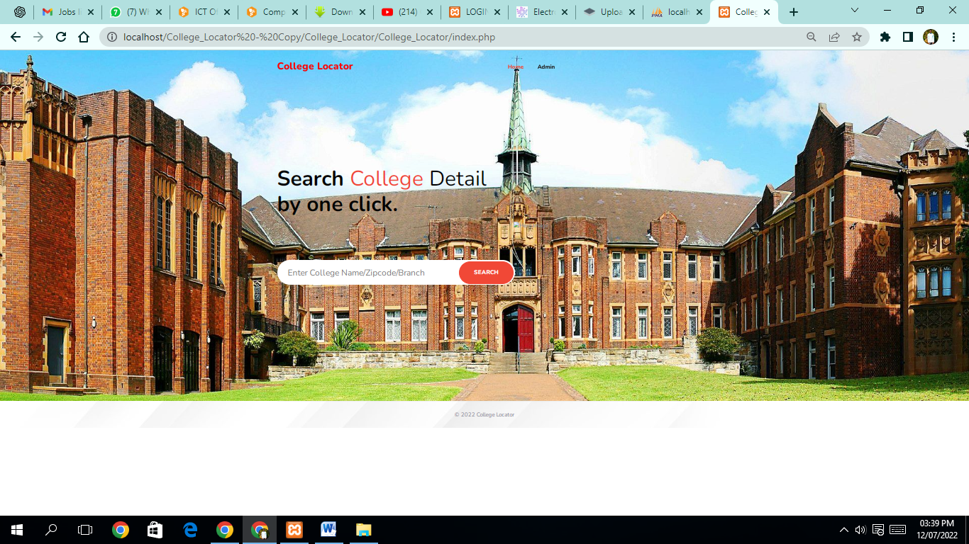

**Search result page:**

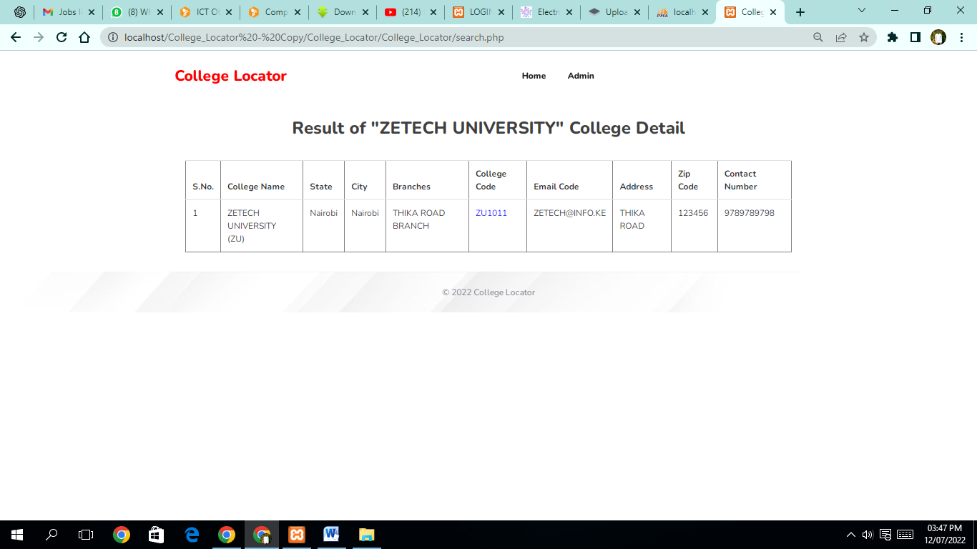

**Admin login page:**

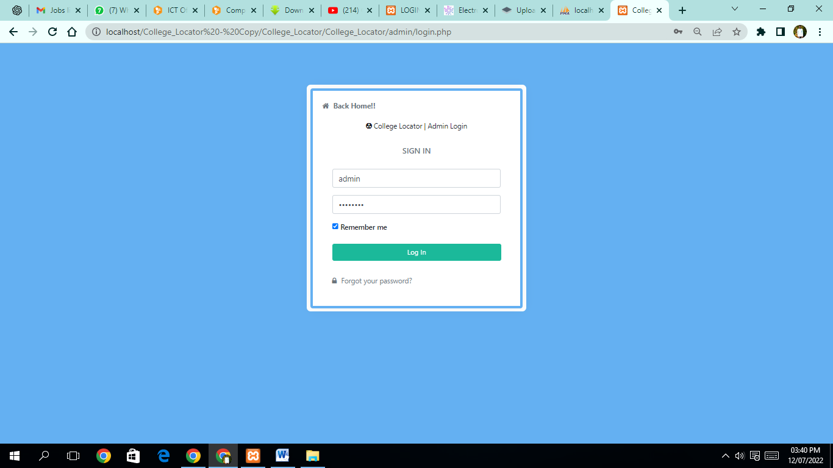

**Admin dashboard:**

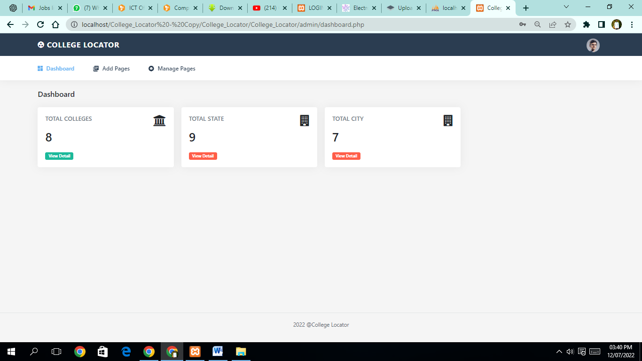

**Admin profile page:**

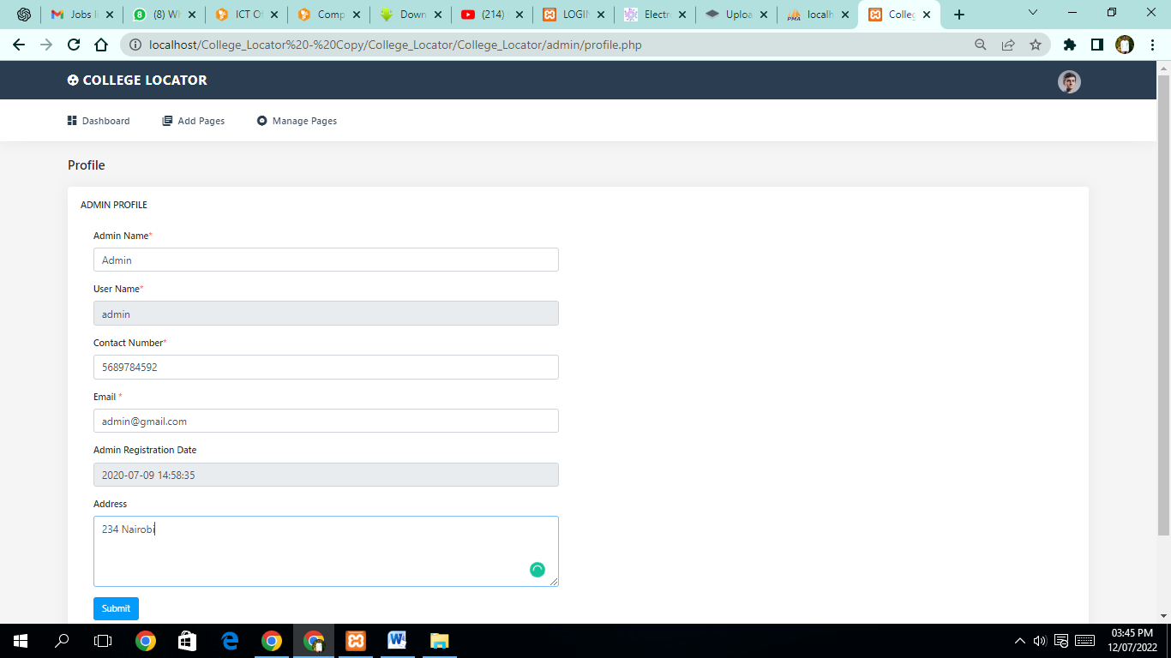

**Manage college details page:**

